**First Review**

**S. John Suthan Singh**

**Problem Identification:**

* The problem is that in general edge detectors behave very poorly. While their behaviour may fall within tolerances in specific situations, in general edge detectors have difficulty adapting to different situations. The quality of edge detection is highly dependent on lighting conditions, the presence of objects of similar intensities, density of edges in the scene, and noise.
* While each of these problems can be handled by adjusting certain values in the edge detector and changing the threshold value for what is considered an edge, no good method has been determined for automatically setting these values, so they must be manually changed by an operator each time the detector is run with a different set of data.
* Brain tumors are a heterogeneous group of central nervous system neoplasms that arise within or adjacent to the brain. Moreover, the location of the tumor within the brain has a profound effect on the patient's symptoms, surgical therapeutic options, and the likelihood of obtaining a definitive diagnosis. The location of the tumor in the brain also markedly alters the risk of neurological toxicities that alter the patient's quality of life.

**Motivation:**

Each year more than 200,000 people in the United States are diagnosed with a primary or metastatic brain tumor.

Brain cancer remains one of the most incurable forms of cancer, with an average survival period of one to two years.

The chances of surviving for a person with a brain tumor greatly depends on all of the following:

type of tumor

* Size of the extent
* Location of the tumor
* Presence or absence of metastasis
* Age
* Overall health, and medical history

**Architecture:**

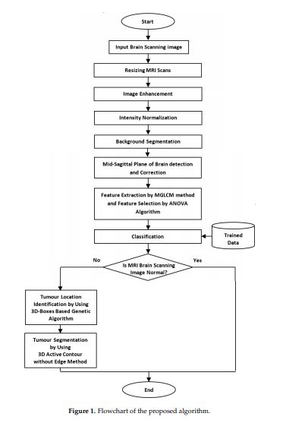

**Tools:**

**MATLAB:**

A proprietary programming language developed by MathWorks, **MATLAB** allows matrix

manipulations, plotting functions and data, implementation of algorithms,

**MATLAB PROFILER:**

The Profiler is a user interface based on the results returned by the profile function. If you are

profiling code that runs in parallel, for best results use the Parallel Computing Toolbox parallel profiler.

**Command prompt:**

Command Prompt is used to execute entered commands. Most of those commands are used to

automate tasks via scripts and batch files, perform advanced administrative functions, and troubleshoot

and solve certain kinds of Windows issues.

**References**

1. M.I. Rajab, M.S. Woolfson, and S.P. Morgan, “Application of re- gion-based segmentation and neural network edge detection to skin

lesions,” *Computerized Medical Imaging and Graphics*, vol. 28, pp. 61–68, 2004.

1. H. Tang, E.X. Wu, Q.Y. Ma, D. Gallagher, G.M. Perera, and T. Zhuang, “MRI brain image segmentation by multi-resolution edge detection and region selection,” *Computerized Medical Imaging and Graphics*, vol 24, pp. 349–357, 2000.
2. Huertas, A. and Medioni, G., “Detection of intensity changes with sub pixel accuracy using Laplacian-Gaussian masks,” *IEEE Trans. On Pattern Analysis and Machine Intelligence,* PAMI, vol. 8, pp. 651–664, 1986.
3. Maragos P., “Differential Morphology and Image Processing,” *IEEE Trans Image Processing*, vol. 5, pp. 922–937, June 1996.
4. Ortiz F, and Torres F, “Vectorial Morphological Reconstruction for Brightness Elimination in Colour Images,” *Real-Time Imaging*, vol. 10, pp. 379–387, June 2004.
5. Jing Xiao-jun, Yu Nong, and Shang Yong, “Image Filtering Based on Mathematical Morphology and Visual Perception Principle,” *Chinese Journal of Electronics*, vol. 13, pp. 612–616, April 2004.
6. Richard A P, “A New Algorithm for Image Noise Reduction Using Mathematical morphology,” *IEEE Transaction on Image Processing*, vol. 4, pp. 554–568, March (1995).
7. Chen T., and Wu Q.H., Rahmani-Torkaman R., Hughes J., “A pseudo top-hat mathematical morphological approach
8. to edge detec- tion in dark regions,” *Pattern Recognition*, vol. 35, pp. 199-210, 2002.
9. Rivest Jean, “Morphological Operators on Complex Signals,” *Signal Processing*, vol. 84, pp. 133–139, January 2004.
10. J. Serra, *Image Analysis and Mathematical Morphology*, Academic Press, New York, 1982.
11. Lee J.S.J., Haralick R.M., and Shapiro L.G., “Morphological Edge Detection,” *IEEE J. Robot. Automat*, vol. 3, pp. 142–156, February 1987.